Modifying CSS Stylesheets For CalcXML-Hosted Calculators

Here are some steps to help you modify the css stylesheet for your CalcXML calculator pages.

- Go to this web page and select a calculator that you would like to use as a sample for your css modifications. (http://www.calcxml.com/english.htm)
  - Click on the calculator link of your choice to display the calculator input page.
  - In the address bar of the browser, append ?skn=XX, where XX is your skn number and then press Enter. This will get rid of the Google Ads from the page. (If you don’t know your skn number, please contact CalcXML.)
- Enter some dummy input values into the input fields and click Submit.
- You will now have the input and output on the same page. At this point, you will want to save this file to your local hard drive. This will be your test html file as you make changes to the css file. It will allow you to make changes locally on your computer and see the effects immediately without having to send us the css file and have us upload it to our servers each time.
  - Go to the File menu of the browser and select Save As…
  - Select a name and location on your hard disk for the html file.
- Now open the html file you just saved with a text editor.
  - Search for the reference to the css stylesheet in the file. It may look something like this: <link rel="stylesheet" href="../css/samples/sample-styleXX.css" type="text/css" media="screen, print">
  - Change the value of the href to point to the stylesheet that you will be editing and then save the changes and close the html file.
- Begin making the desired changes to the stylesheet. When you want to view the effects of the changes, just open the saved html file in a browser.

To help you identify which css styles are associated with which parts of the input/output sections, please see the pictures below.
Sample input section showing CSS style elements

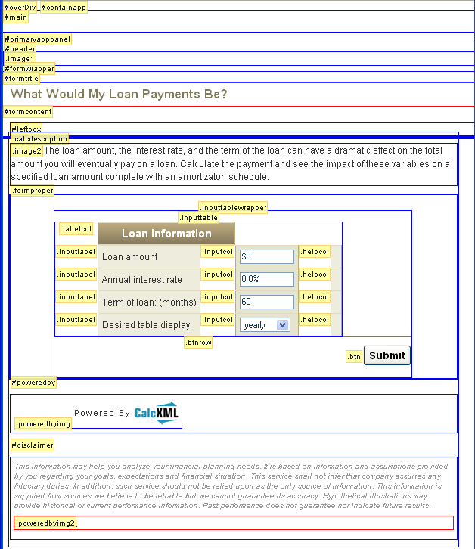

Sample output section showing CSS style elements

